# Introduction to the Climate System

The 6 Trench-Ed lessons and visualizations help students develop an understanding of specific responses of organisms to warming associated with climate change, and what this means on a global scale.

Two of the Trench-Ed lessons/visualizations connect directly to aspects of the physical climate system.

1. [Metabolic Impacts of Climate Change](https://insectphenology.ml/Climate-Change-Metabolism/)

As part of this lab students think about observations of climate change and models of future climate change, that show faster warming toward the poles. Students think about what this means for organisms and their metabolic rates.

1. [Energy Budgets: Understanding the heat budget of montane butterflies](https://huckley.shinyapps.io/RShiny_ButterflyAdvanced/)   
   The background covers the heat budgets of organisms and a discussion of albedo, feedback, and heat. It reviews how organisms can maintain homeostasis in a changing climate.

## A brief primer on climate change

Students can use the introduction and [visualizations of indicators of climate change](https://trench-ed.github.io/#climate-change) to become familiar with the impacts of climate change on the planet. Included below are some questions to guide exploration of the visualizations as well as resources for delving deeper.

The climate system is complex and affects and is affected by many processes operating on different temporal and spatial scales. Some of these ideas are explored here, along with basic information that supports understanding the connection between increasing CO2 and temperature, latitudinal gradients in warming that affect biological processes, destruction of habitat, and more.

Invite students to read through the [Climate Change page on the Trench-Ed](https://trench-ed.github.io/#climate-change) website, while also clicking through the four indicators of a changing climate (sea ice, sea level, carbon dioxide and global temperature).

## Outline

1. Sea ice
   1. What the data show about impact of warming on Arctic sea ice;
   2. How ice melting can feedback to the climate system;
   3. Consider different forms of ice on earth and which impact sea level rise.
2. Sea Level
   1. What factors associated with global warming result in rising sea levels?
   2. How is and will sea level rise impact coastlines in different places?
3. CO2
   1. How do we know CO2 is rising in the atmosphere? How do we know what CO2 has been in the past?
   2. What causes atmospheric CO2 concentrations to vary on seasonal time scales? What has caused atmospheric CO2 concentrations to increase since pre-industrial times?
4. Global Temperature
   1. Ice core records provide clear evidence that earth’s temperature is closely tied to atmospheric CO2 concentrations.
   2. Current records document the rise in global temperatures, as well as latitudinal gradients.
   3. Latitudinal gradients (link to info in Metabolism/Temperature Visualization)
5. More Climate Change Indicators (link to a visualization tool that many teachers will already be familiar with)
6. Explanation of feedbacks and link to more lessons on the climate system, if teachers are looking for additional online resources for teaching. Chemistry focus, but generally accessible.

## Sea Ice

Q. Where does sea ice form? Where are glaciers formed? Why is this difference important when we think of the physical impacts of global warming?

* What effect would you expect global warming to have on the annual minimum extent of sea ice in the Arctic?
* Use the visualization of the annual sea ice minimum in the Arctic to see how it is changing. Why is this change concerning?
* After clicking the play button on the visualization, what do you notice about how the sea ice is changing in the Arctic over time?
* What role do you think sea ice plays in Earth’s radiation balance? Do you think a surface that is white like ice, or darker like ocean water, would absorb the more of the sun’s heat? Why?
* What do you predict the impacts of that change could be?

## Sea Level

Q. Global warming is melting glaciers and sea ice. As air temperatures rise so does the temperature of the oceans. Not all of these contribute to sea level rise. Explain.

After clicking on “Sea Level” you see a map. There are four maps which show which sections of land will be underwater (shown in red) if the Greenland Ice Sheet melts completely in the next century.

* Southeast United States – what important cities, landmarks, etc will be underwater with this level of ice melt?
* Northern Europe – which countries could be particularly hard hit by the melting ice sheet?
* Amazon Delta – If the Amazon forest is considered “the lungs” of the planet – taking in lots of carbon dioxide and breathing out lots of oxygen – what could the impact of the rise in sea level here mean for the world?
* Southeast Asia – These islands show many islands that are part of Malaysia, Indonesia and other nations. This part of the world is very populous. If the sea level rises significantly on these islands, what could the impact be?

## Carbon Dioxide - How do we know CO2 is increasing?

DIfferent strategies for measuring CO2 help us visualize how it is changing on different time scales.

* Satellite measurements, those used on the [Climate Change page on the Trench-Ed](https://trench-ed.github.io/#climate-change) website, are from the [AIRS satellite.](https://airs.jpl.nasa.gov/)
* Direct measurements of atmospheric CO2 (Keeling Curve)
* CO2 trapped in ice

Explore the NASA Climate Time Machine graphic. Clicking on the carbon dioxide tab, push play on the time lapse.

Q1. What do you notice is happening to the concentration of carbon dioxide around the world?

Q2. Why would it change from year to year? on other shorter or longer time scales?

Q3. Where in the world does the concentration seem to be the highest? What could the impact of that be to the environment?

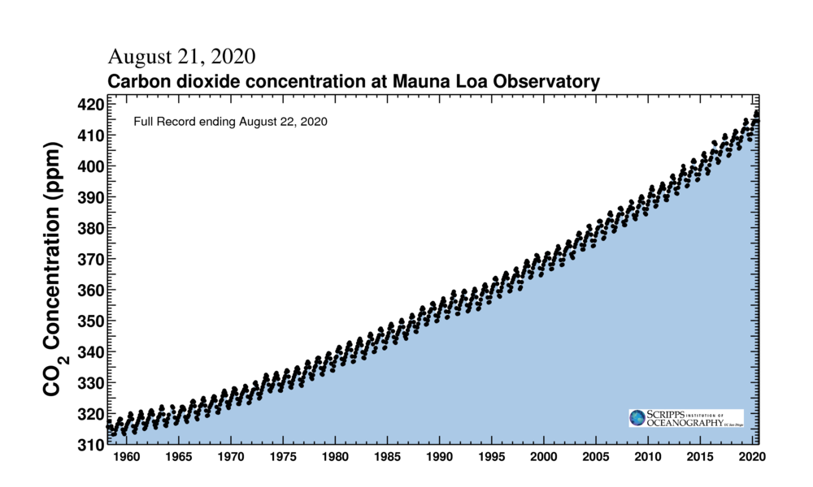

The graph on the right shows [seasonal variations in atmospheric CO2 measured over Mauna Loa](https://scripps.ucsd.edu/programs/keelingcurve/) due to biological processes in the northern hemisphere; you can also see that CO2 is and has been increasing rapidly.

## Global Temperature

Explore temporal and spatial temperature variations as measured by satellite.

After clicking on the global temperature tab, push play on the time lapse.

Q. Where in the world is the global temperature rising more dramatically (especially at the end of the time lapse)?

Connect this back to what we saw in the first two visualizations – sea ice and sea level rise:

Q. how are these connected to what you are seeing here?

Ice core data can be combined with recent direct measurements to show how CO2 and temperature change together.

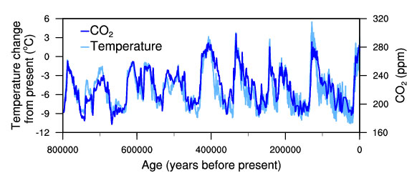

[**https://www.ncdc.noaa.gov/global-warming/temperature-change**](https://www.ncdc.noaa.gov/global-warming/temperature-change)

## More Climate Change Indicators

As humans continue to add greenhouse gases, like carbon dioxide to the atmosphere, is this increasing or decreasing the following?

* Sea Ice Melting
* Sea Level Rise
* Temperature

Explore other climate change indicators with the interactive graphic you can access through this link: <https://www.globalchange.gov/indicators>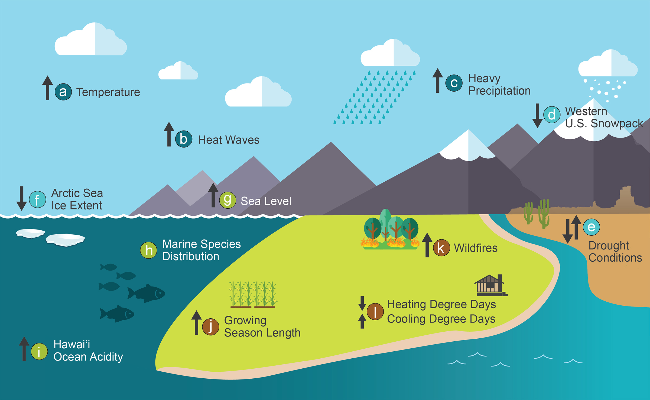

## Feedbacks in the Climate System

Feedback definition slightly adapted from Schmidt and Wolfe, Climate Change, Picturing the Science 2009, pg 11.

“The concept of feedback is at the heart of the climate system and is responsible for much of the complexity of the system. In the climate everything is connected to everything else, so when one factor changes, it leads to changes in other components which can affect the initial factor that started the chain of reactions. If this feedback amplifies the initial change, it is described as a positive feedback; if it dampens the change it is a negative feedback.”

Ice-albedo feedback is a classic example of a positive feedback-snow and ice melt as the planet warms, and because they reflect more sunlight (have a higher albedo) than the now-exposed ocean or land, less solar energy is reflected, further warming the planet. See also discussion of albedo in Energy Budgets: Understanding the heat budget of montane butterflies. <https://huckley.shinyapps.io/RShiny_ButterflyAdvanced/>

Here is a longer lesson on climate feedbacks, that, if there is time in a class, teachers could use all or part of.

<https://explainingclimatechange.com/lesson7/lesson7.html>